|  |  |
| --- | --- |
| **TEAM ID** | **PNT2022TMID08806** |
| **TITLE** | **HAZARDOUS AREA MONITORING FOR**  **INDUSTRIAL PLANT POWERED BY IOT** |

**IBM Watson IoT Platform and Device**

* It is powerful web dashboard Flexible, scalable and easy to use.
* We provide a clean and simple UI where you can simply and easily add and manage your devices, control access to your IoT service, and monitor your usage. See at aglance the things you are interested in. • It can do some:

# Device Management

* Using our device management service, you can perform device actions like rebooting or updating firmware, receive device diagnostics and metadata, or perform bulk device addition and removal.

**Responsive, scalable connectivity**

* We use the industry-standard MQTT protocol

(OASIS ratified) to connect devices and applications. MQTT is designed for efficient exchange of data to and from devices in real-time.

# Secure Communication

* Securely receive data from and send commands toy our devices. Do this using MQTT with TLS to secure all communication between your devices and our service.

**Data lifecycle management**

* As well as having access to real-time data coming from your devices, you can opt to store data for a period of your choice, allowing you to have access to historical and real-time data for your devices.

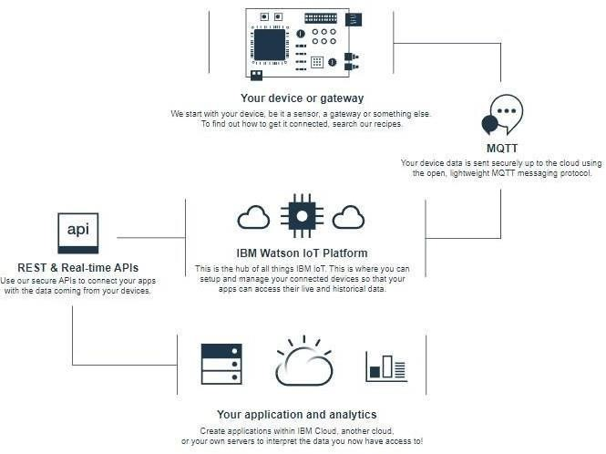

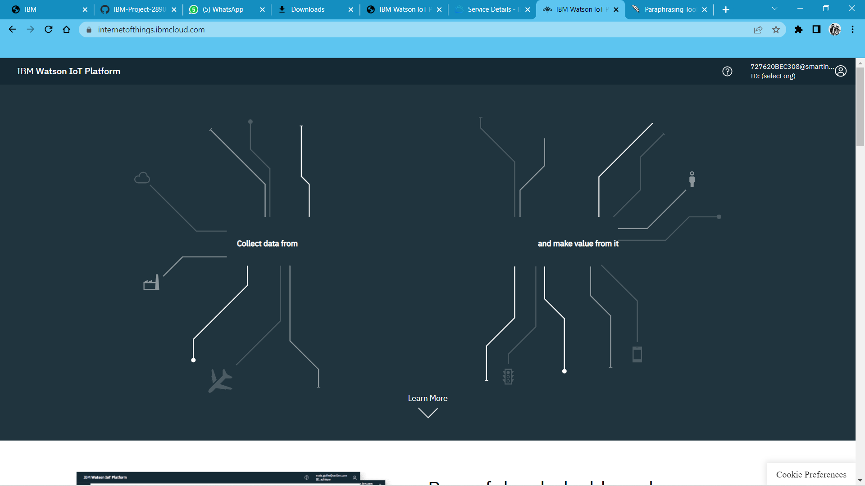

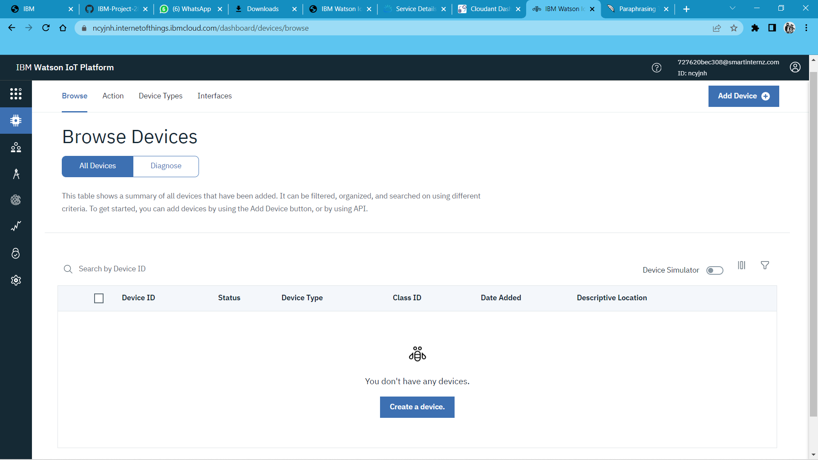

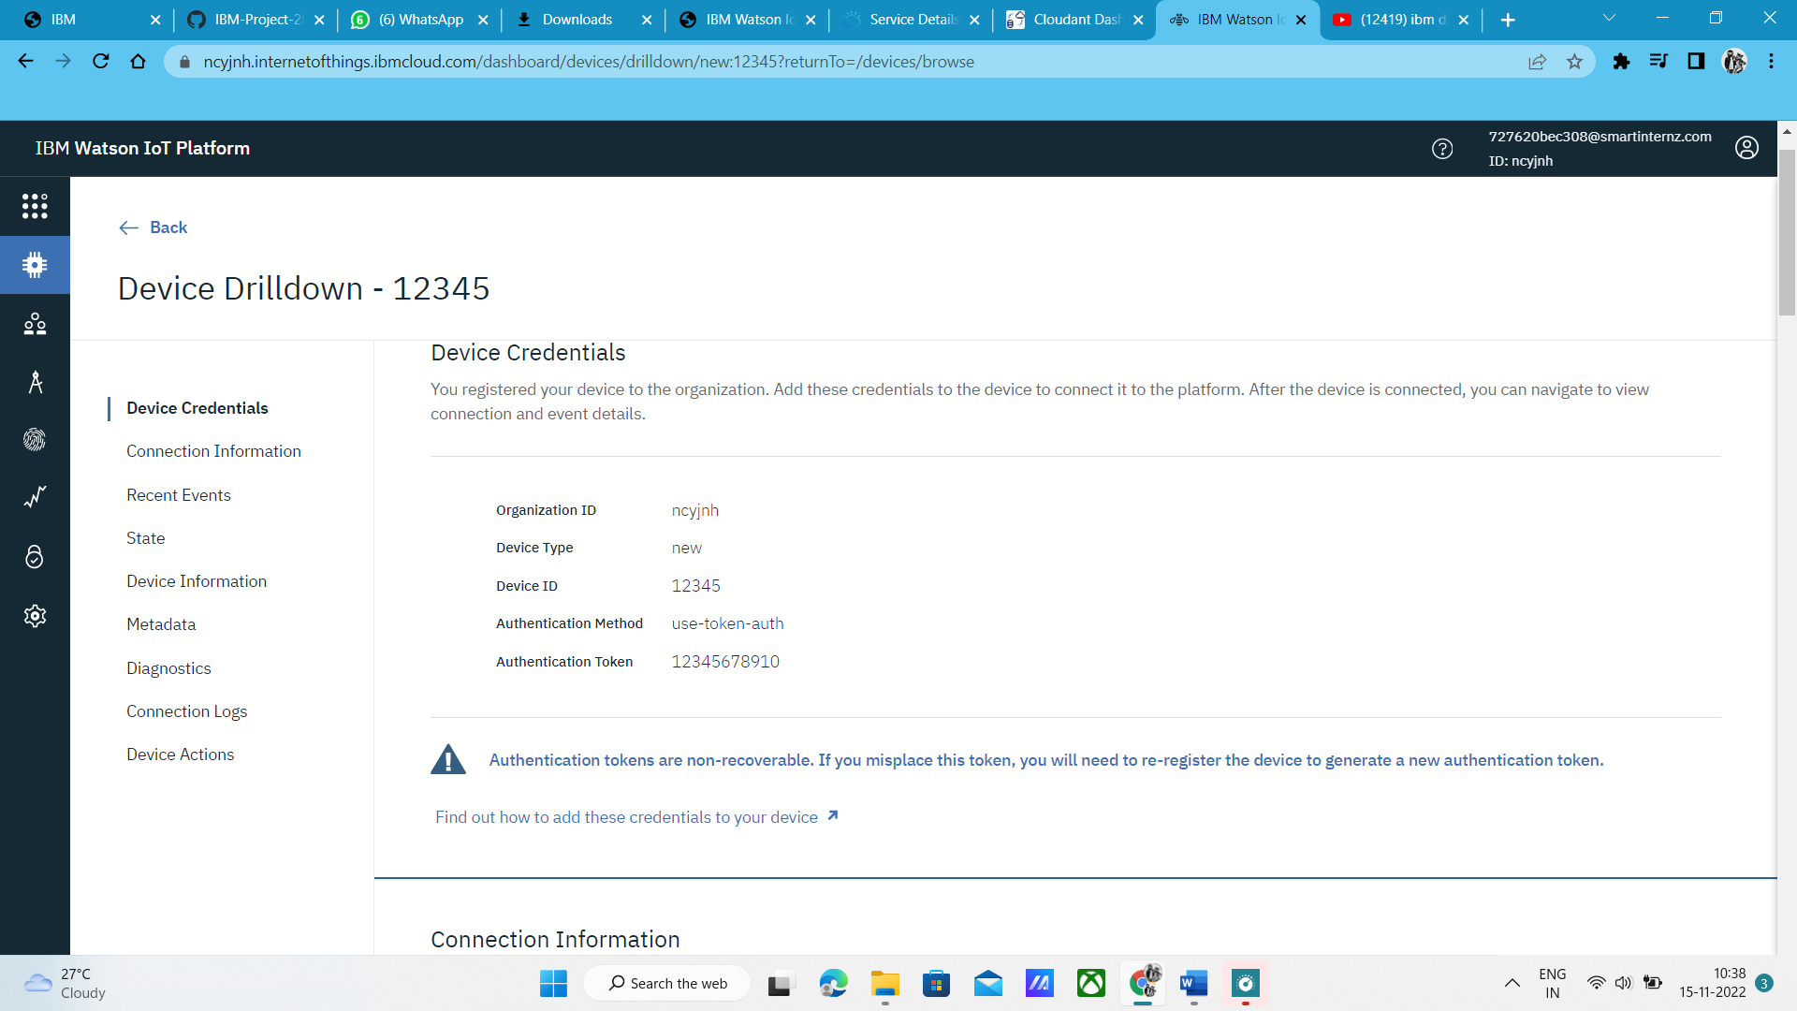

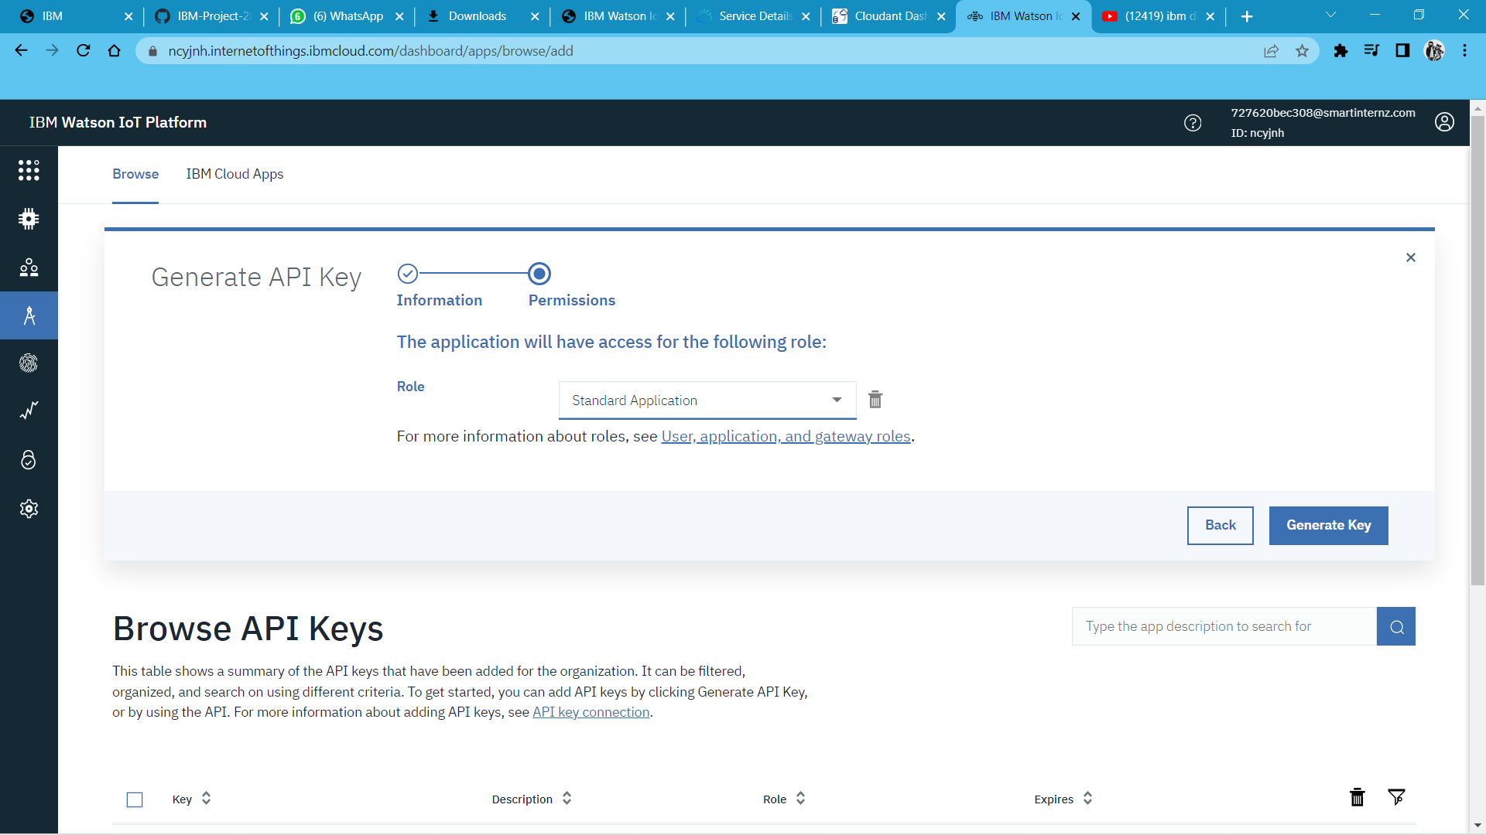

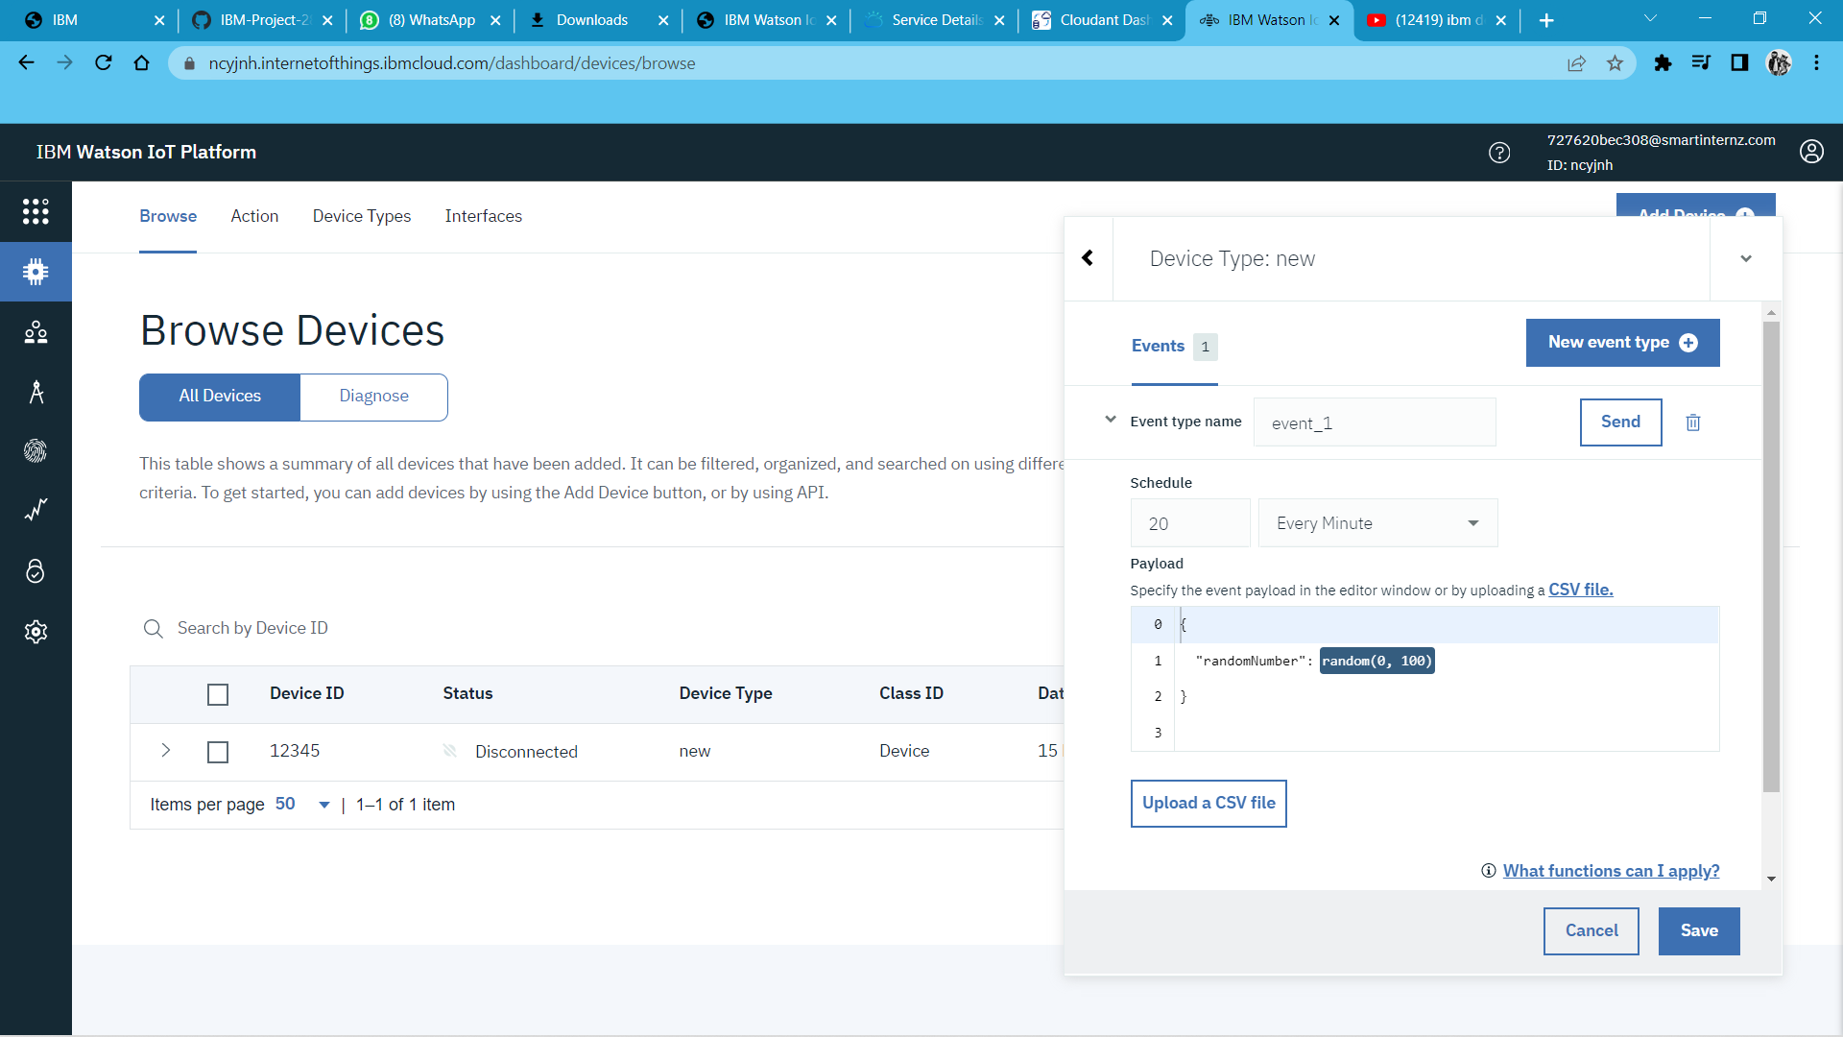

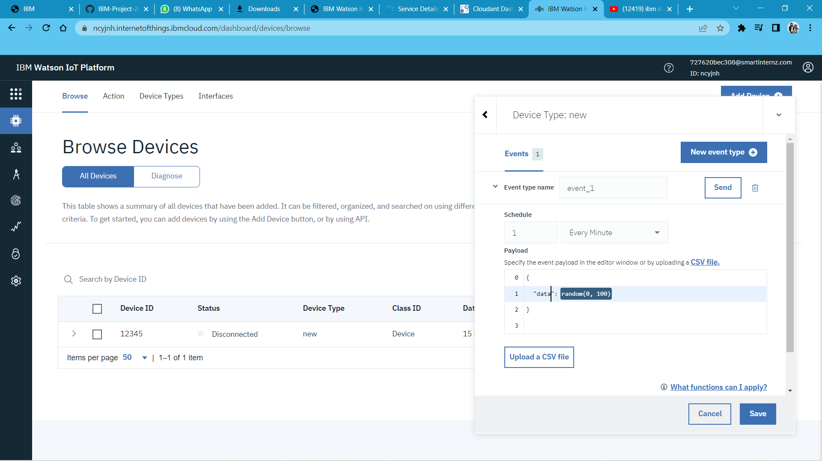

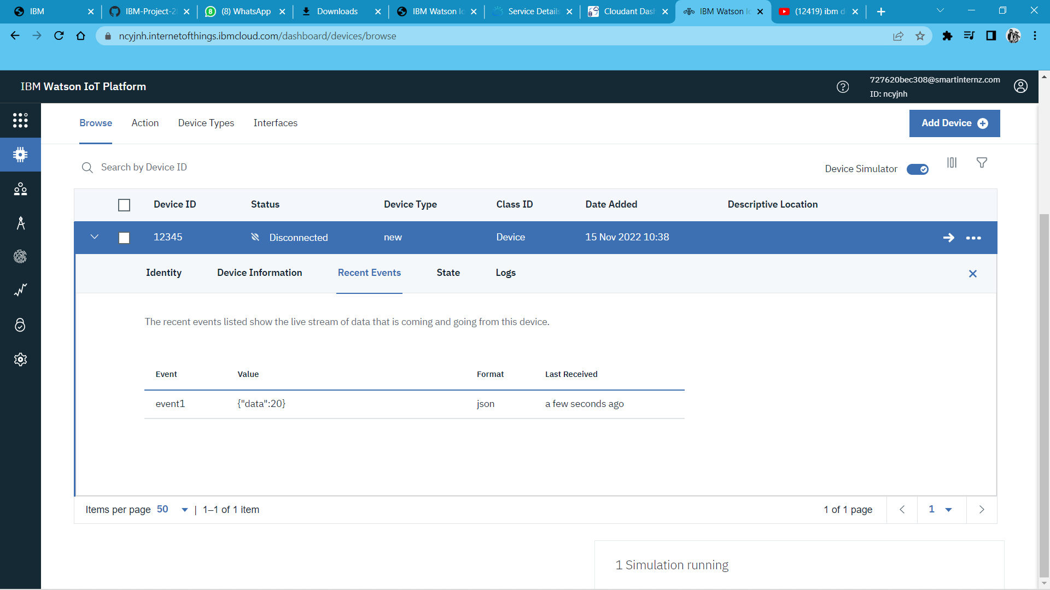

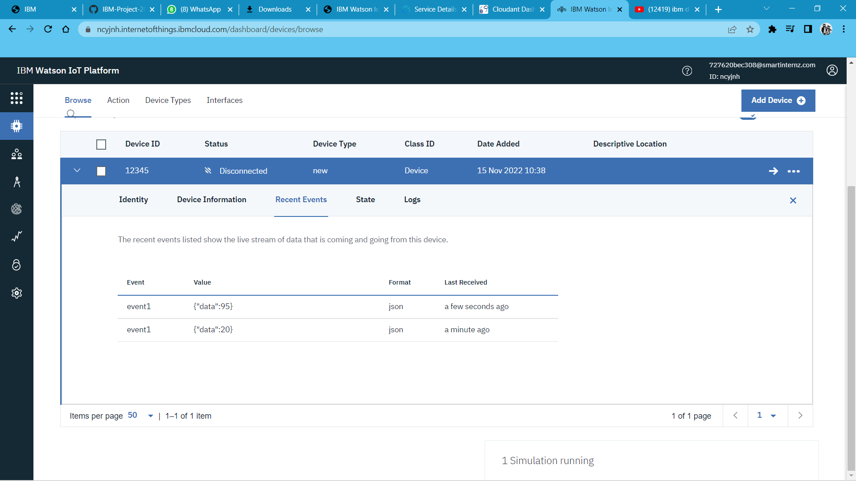

**Thus we created IBM Watson IoT Platform and Device.**